**Customer as person**

**Artis Planetarium as:**

* Man and Woman.
* Single.
* Dutch (or English).
* 10 years old.
* An European look.
* At the moment studying at elementary school.
* Loves looking at the stars at night, loves gaming and loves to learn.
* Lives with parents.
* 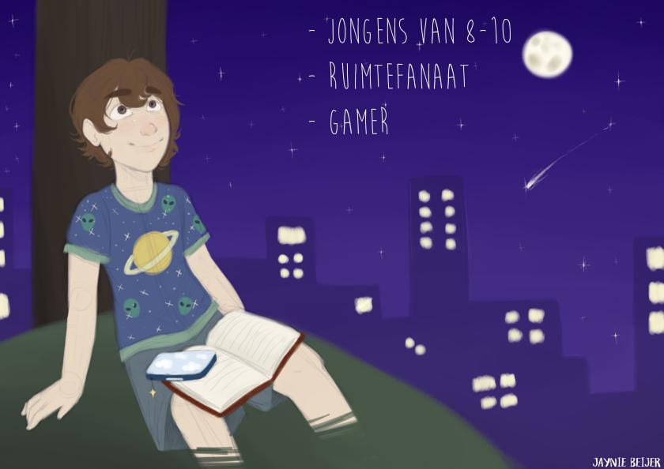Uses his parents their computer to play games and watch YouTube videos.